|  |  |
| --- | --- |
| Date | 10 October 2022 |
| Team ID | PNT2022TMID30411 |
| Project Name | IOT Based safety gadget for child safety monitoring and Notification |

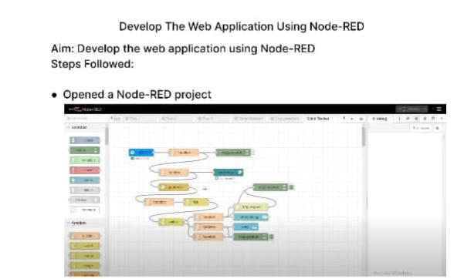**Develop the web application using Node-Red**

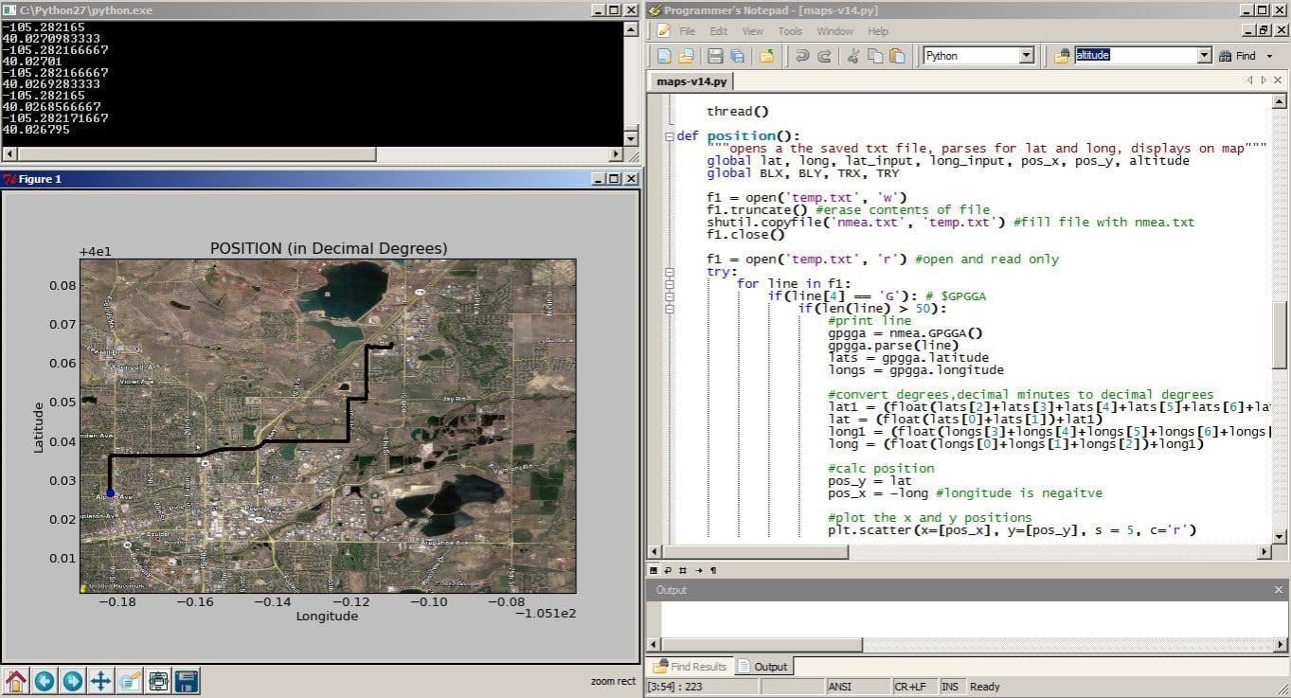**Added a python code to get a child location**

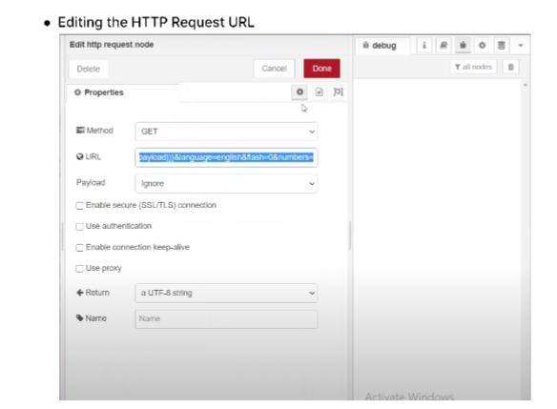

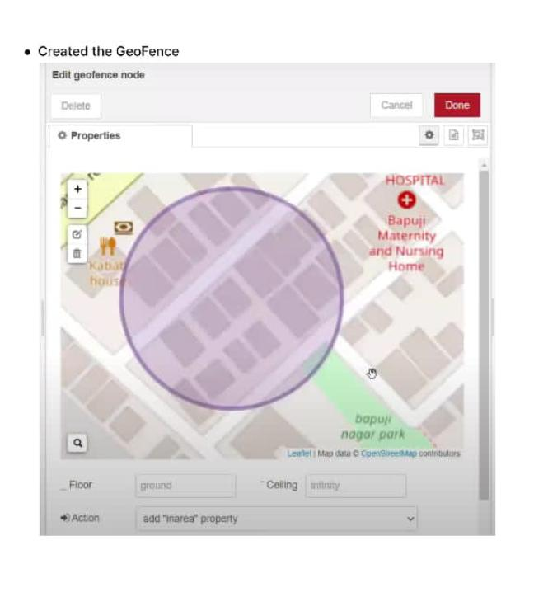

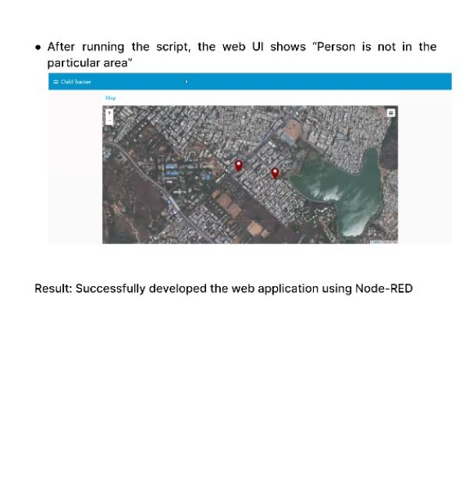

**Result: Successfully developed the web application using NODE-RED**